Exercise - 7 : Financial Forecasting Using Recursion

**Recursion :**

1. Recursion refers to the process of a function calling itself. This technique is mainly used in problems where we have to explore multiple possible paths or for calculating the result of a problem by using the results of it’s reduced sub-problems.
2. In our case, we will be forecasting the value of a given principle amount that is invested in compound interest.
3. The code will contain a recursive function that will be used to calculate the value of compound interest gained by the user after investing his principal amount for a given number of years at a predefined rate of interest.
4. Actual formula for calculating return amount after adding the compound interest that can be generated within given time period :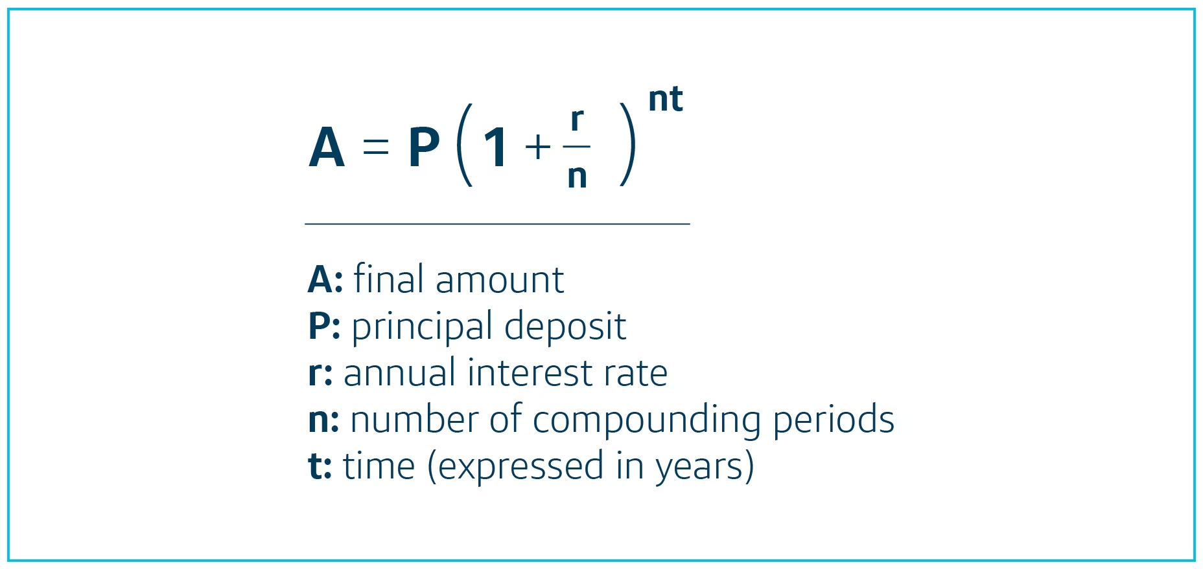

5. Recursive formula for calculating the final amount after adding the compound interest :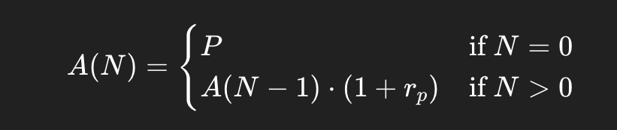

**Recursive Code :**

// Recursive function to compute compound interest

// Here, tp->time period, p->principle amount, r->rate of interest

public static double find_comp(int tp, double p, double r) {

if (tp == 0) {

return p;

}

return *find_comp*(tp - 1, principal,r) * (1 + r);

}

**Complexity Analysis :**

Time Complexity : O(n)

* This is because we are making ’n’ recursive calls starting ’n’ all the way down to ‘0’ (base case)
* Here, ’n’ actually refers to the number of time periods we are taking into consideration.

Space Complexity : O(n)

* This is due to stack space being taken up by the ’n’ recursive calls that we discussed above i.e., for each recursive call , an activation record will be created and pushed onto the stack thereby making the space complexity O(n).

**Improvement :**

* We can convert our recursive approach to an iterative one by constructing the solution in a bottom-up way.
* This way, we can eliminate the need to use O(n) stack space by simply using an ‘amount’ variable to track the changes in each step.
* However, the time complexity will still remain same i.e., O(n)
* But space complexity will become linear i.e., O(1)

**Code :**

package org.example;

import java.util.Scanner;

public class Main {

// Recursive function to compute compound interest

public static double find_comp(int tp, double p, double r) {

if (tp == 0) {

return p;

}

return *find_comp*(tp - 1, p,r) * (1 + r);

}

public static void main(String[] args) {

Scanner scanner = new Scanner(System.*in*);

System.*out*.println("--Finacial Forecasting of Compound Interest---");

// User input

System.*out*.print("Enter initial investment (principal) : ");

double principal = scanner.nextDouble();

System.*out*.print("Enter annual interest rate (in %) : ");

double rate_of_interest = scanner.nextDouble()/100.0;

System.*out*.print("Enter number of years for forecasting: ");

int years = scanner.nextInt();

System.*out*.print("Enter compounding frequency (12 for compounded monthly, 4 for quarterly etc): ");

int comps = scanner.nextInt();

// calculation

int periods = years * comps;

double rate_of_interest_per_period = rate_of_interest / comps;

double return_value = *find_comp*(periods, principal, rate_of_interest_per_period);

// output

System.*out*.printf("\nForecasted Value after %d years : %.2f\n",

years, return_value);

scanner.close();

}

}